

LICENSURE EXAMINATION FOR PROFESSIONAL TEACHERS
SEPTEMBER 20, 2026

GURONG PINOY: GENERAL EDUCATION REVIEWER
SOCIAL SCIENCE REFRESHER
(Session 1: April 29, 2026)

DRILLS
Nobel Peace Prize | Maria Ressa  - Rappler  - Freedom of expression  - Democracy  - Expose  - Government abuse of power  - Disinformation authoritarianism | Jesicca Soho  - Filipino broadcast journalist  - GMA Network.
Social Network Service | Google  - a mobile utility  - provides fast access to search  - personalized news  - AI tools | Facebook  - mobile application  - profiles  - connect with others  - generated content (photos, videos, posts)
Population growth will outpace food production | Adam Smith  - the father of modern economics  - study of the relationship between society, politics, commerce and prosperity | Thomas Malthus  - population growth  - outrun the food supply  - betterment of humankind  - impossible without strict limits on reproduction
Stage actress who bought fame to the Philippines because of her international awards | Nora Aunor  - TV actress  - most awarded Filipino actress in history  - Philippines' "Superstar" | Lea Salonga  - Stage actress  - Miss Saigon  - International awards
Which of the following is NOT a painting material? | Etching  - printmaking technique  - engraving or using acid on a surface (usually metal)  - process | Oil  - painting medium/material  - oil paintings
Sala Theater | Naty Rogers  - Sala Theater  - community-based and alternative theater | Cecile Alvarez  - renowned pianist  - music performance,
This concept was made possible by the easy access to travel, rise of mass media and global interconnectedness through technology | Answer: Global village  - by Marshall McLuhan.  - world feels small and connected—like one village because of:  - fast communication  - media  - technology
First indigenous people of  the Philippines | Answer: Negritos/ Aetas  - earliest known inhabitants of the Philippines.  - migrated via land bridges  - Aeta, Agta, and Ati.  - Aboriginals
National artist known for paintings portraying rural life and landscapes | Answer: Fernando Amorsolo  - paintings of rural Philippine life  - bright sunlight and warm colors/ backlighting  - beauty of Filipino traditions and landscapes  Notable Paintings  - Planting Rice  - Shows farmers working in golden rice fields  - A perfect example of Filipino rural life  - Rice Planting  - Similar theme—community farming and bayanihan spirit  - Bright sunlight and peaceful countryside  - The Making of the Philippine Flag  - Historical painting showing Emilio Aguinaldo and others preparing the flag  - Combines history with his signature lighting  - Dalagang Bukid (Country Maiden)  - Portrait of a Filipina in traditional attire  - Represents beauty and simplicity of rural women  - Marketplace  - Depicts everyday life in a local village market  - Lively and full of cultural detail
What was the name of forced labor imposed during the Spanish regime? | Answer: Polo y Servicio  - forced labor system during the Spanish colonial period  - Filipino males (usually 16–60 years old) were required to work for 40 days a year (later reduced)  - build roads, bridges, ships (galleons), and churches.  Tributo  - a tax  Encomienda  - a land and tribute system  Bandala  - forced selling of goods to the government
Contradictory emotional or psychological attitude may lead to | Answer: Ambivilence  - mixed or contradictory feelings at the same time



LICENSURE EXAMINATION FOR PROFESSIONAL TEACHERS
SEPTEMBER 20, 2026

GURONG PINOY: GENERAL EDUCATION REVIEWER
SOCIAL SCIENCE REFRESHER
(Session 1: April 29, 2026)

LET QUESTIONS WITH RATIONALIZATION

1. The Philippine president who signed the Rizal Law is?
- Quezon
- Roxas
- Macapagal
- Magsaysay

Rationalization:
- Republic Act No. 1425 or the Rizal Law
- signed by President Ramon Magsaysay
- include in the curricula
- public and private schools, colleges and universities
- courses on the life, works and writings of Jose Rizal
- novels Noli Me Tangere and El Filibusterismo
- Proposed by Senator Claro M. Recto, The Great Dissenter
- Catholic Bishops' Conference of the Philippines (CBCP) strongly oppose the bill,
- church
- Fr. Jesus Cavanna, argued: 333 pages of the Noli Me Tangere, only 25 are nationalistic, while 120 are anti- catholic

2. Where was Jose Rizal born?
- Dapitan
- Calamba
- Bagumbayan
- Binan

Rationalization:
- Calamba- This is Rizal’s birthplace and referred to as cradle of a hero. His full name is José Protacio Rizal Mercado y Alonso Realonda, and he was born in Calamba, Laguna on June 19, 1861.
- Dapitan is where Rizal was exiled
- Bagumbayan (now Luneta or Rizal Park) is the site of his execution on December 30, 1896.
- Biñan is where Rizal studied under Maestro Justiniano Aquino Cruz during his early education
- Rizal is the 7th among 11 children
- Saturnina Rizal (Eldest sister)
- Paciano Rizal (Older brother) – close confidant and supporter of José
- Narcisa Rizal
- Olympia Rizal
- Lucia Rizal
- Maria Rizal
- José Rizal (the hero himself)
- Concepción Rizal (died at a young age)
- Josefa Rizal
- Trinidad Rizal
- Soledad Rizal (youngest sibling)
- Father: Francisco Mercado
- Mother: Teodora Alonso Realonda

3. In this university, Rizal obtained his licentiate in Medicine.
- University of Sto. Tomas
- Ateneo de Manila University
- Universidad Central de Madrid
- University of Heidelberg

Rationalization:
- Rizal’s Educational History
- Home/Bahay- First Teacher is his Mother Teodora Alonso Realonda
- Binan, Laguna- Maestro Justiniano Aquino Cruz
- Ateneo de Municipal- Highscool, Bachelor of Arts, Heswitang Pari
- University of Sto. Tomas- College, Philosophy and letter then shift to Medicine, Dominikanong pari
- Universidad Central de Madrid- Medicine, Philosophy and letter

4. The heaven-sent financer of Noli Me Tangere is?
- Rufino Collantes
- Valentin Ventura
- Pedro Casanas
- Maximo Viola

Rationalization:
- Máximo Viola: Noli Me Tangere
- Valentin Ventura: El Filibusterismo
- MV: NOLI; VV: ELFILI

5. El Filibusterismo, Rizal’s second novel and a sequel to the NOLI and more revolutionary and tragic than the latter, was printed in?
- Spain
- Berlin
- Belgium
- Rome

Rationalization:
- Berlin: Noli Me Tangere
- Belgium: El Filibusterismo
- NO Ligo: BER months (Berlin)
- BELGIUM waffles: FILlings (El fili)

6. El Filibusterismo is the sequel of Noli Me Tangere and like the first book, it was written in Spanish. To whom did he dedicate this second novel?
- To his beloved parents
- To the suffering Filipino people
- To the executed Filipino priests
- To his love, Leonor Rivera

Rationalization:
- Noli Me Tangere: Dedicated to the Philippines (Inang Bayan)
- El Filibusterismo: Dedicated to Gomburza (Gómez, Burgos, Zamora)

7. What did Rizal do with the Antonio de Morga’s book entitled, “Succesos de las Islas Filipinas” at the British museum?
- A. Criticize it
- Borrowed and brought it home
- Copied, annotated, and published it
- Vandalized and burned it

Rationalization:
- Rizal’s work on Morga’s book = Copy + Annotate + Publish
- Purpose = Reveal the true pre-colonial history of the Philippines

8. In The Philippines a Century Hence, Rizal predicted that if Spain failed to reform, the Philippines might fall under:
- Religious leaders
- Isolationist governance
- Another colonial power
- Indigenous tribes

Rationalization:
- Rizal’s warning
- No reforms: loss of Spain’s control
- Possible takeover by another colonial power

9. In his poem Himno al Trabajo, Jose Rizal emphasizes the dignity of labor as a unifying force for the people of?
- Lipa, Batangas
- Dapitan
- Calamba, Laguna
- Kawit, Cavite

Rationalization:
- Himno al Trabajo: Lipa, Batangas (origin/dedication)
- Rizal’s “labor advocacy in action”: Dapitan (application)

10. Who was the Governor-General who ordered the death of Rizal?
- Ramon Blanco
- Eulogio Despujol
- Rafael Izquierdo
- Camilo Polavieja

Rationalization:
- Despujol – Dapitan
- Polavieja - Patay

11. In his poem, “The Intimate Alliance Between Religion and Good Education”, Rizal showed the importance of religion in education. Which of these is a valid main topic for the poem?
- Education without God is not true education
- Religion without education is not a true education
- Education without God is allowable
- Religion without education is allowable

Rationalization:
- Rizal’s message: Education + Religion = Complete formation of a person
- Without God/morality, Education is incomplete

12. Which best describes the division of the legislature into the Senate and House of Representatives?
- Bicameralism
- Bipartisanship
- Unicameralism
- Co-legislative

Rationalization:
- Upper House → Senate
- Lower House → House of Representatives
- Bi = Two → Bicameral = Two chambers (Senate + House)
- Bipartisanship: cooperation between two political parties
- Unicameralism: Means a single legislative chamber
- Co-legislative: Refers to bodies (like the executive) that share in lawmaking powers

13. What form of government is the principle of the separation of powers?
- Parliamentary
- Aristocracy
- Presidential
- Monarchy

Rationalization:
- Legislative (makes laws)
- Executive (implements laws)
- Judicial (interprets laws)
- Separation of powers: Presidential system
- Fusion of powers: Parliamentary system
- Rule by a privileged class: Aristocracy
- Power is concentrated in a king or queen: Monarchy

14. Participation in governance, including the right to vote and seek public office is secured within citizenry’s
- Right to due process
- Socio-civic rights
- Political rights
- Rights to suffrage

Rationalization:
- Political rights = Vote + Run for office + Participate in governance
- Right to due process: Refers to fair treatment under the law
- Socio-civic rights: relates to social welfare and community participation
- Rights to suffrage: refers only to the right to vote
- Civil = “C for Citizen as a person”
- Political = “P for Power in government”

15. The Brundtland Commission highlighted the development that meets the needs of the
present without compromising the ability of the future generation to meet their own needs.
- Uncompromising development
- Healthy development
- Sustainable development
- Progressive development

Rationalization:
- Brundtland definition = Sustainable development
- Focus: Balance between present needs and future sustainability

16. Companies that own a home company and its subsidiaries emphasizing a centralized strategy, are called________________.
- Multinational companies
- National companies
- International companies
- Transnational companies

Rationalization:
- Multinational companies: with a home/original company example starbucks
- Transnational companies: with many companies, adapt to the countries example Unilever

17. Which was formed during the Cold War to counter the threat of the Soviet Union?
- ASEAN
- NATO
- SEATO
- APEC

Rationalization:
- The organization formed during the Cold War to counter the perceived threat of the Soviet Union was the North Atlantic Treaty Organization (NATO).
- ASEAN: The Association of Southeast Asian Nations was formed in 1967 to promote economic and regional cooperation in Southeast Asia.
- SEATO: The Southeast Asia Treaty Organization (1954) was also a Cold War alliance, but it focused on Southeast Asia and is no longer active.
- APEC: The Asia-Pacific Economic Cooperation is an economic forum established in 1989 to promote free trade and economic cooperation.

18. What is meritocracy?
- Culture of elitism
- Rule of the nobles
- Rule of the talented
- Rule of the wealthy

Rationalization:
- Meritocracy: “You rise based on what you can do, not who you are or what you have.”
- Culture of elitism: based on privilege or social superiority
- Rule of the nobles: aristocracy, where power is held by noble birth
- Rule of the talented: means “rule by merit,” where the most capable or qualified individuals are selected
- Rule of the wealthy: describes plutocracy, where wealth determines power.
- Forms of Government:
  - MONARCHY – one
  - ARISTOCRACY – few, noble blood, high class status, elitism
  - OLIGARCHY – business
  - DEMOCRACY – many
  - THEOCRACY – religious
  - ANARCHY – no gov

19. Who is the most famous proponent of the Arena theater in the Philippines?
- Montano
- Avellana
- Tinio
- Carpio

Rationalization:
- Severino Montano, Arena Theater
- Father of Philippine Regional Theater
- Avellana: Lamberto Avellana is a National Artist for Film and Theater, known for cinematic direction
- Tinio: Rolando Tinio is known for translation, poetry, and theater design

20. Who among the Filipino writers below focuses on the beliefs and traditions during the Filipino Spanish period?
- Nick Joaquin
- Bienvenido Santos
- NVM Gonzales
- F. Sionil Jose

Rationalization:
- Nick Joaquin: wrote historical and cultural narratives that explore the Spanish colonial past, blending myth, religion, and Filipino identity. Famous works include The Woman Who Had Two Navels and A Portrait of the Artist as Filipino.
- Bienvenido Santos: focuses on Filipino diaspora and experiences of Filipinos abroad, especially in the U.S.
- NVM Gonzales: Known for rural life and Filipino everyday struggles, especially provincial settings.
- F. Sionil Jose: Focuses on social injustice, class struggle, and Philippine society across generations, not specifically the Spanish period.

21. Tao Te Ching is the principal literary work of Taoism which is written by
- Confucius
- Gautama Buddha
- Mahatma Gandhi
- Lao Tzu

Rationalization:
- Lao Tzu: He is credited with writing the Tao Te Ching, which teaches living in harmony with the Tao (the “Way”).
- Confucius: He is the founder of Confucianism, which focuses on ethics, social harmony, and proper conduct.
- Gautama Buddha: He founded Buddhism, which teaches the Four Noble Truths and the Eightfold Path.
- Mahatma Gandhi: He was an Indian independence leader who promoted nonviolence (ahimsa), not Taoism.

22. He was referred to as the “Brains of Himagsikan”
- Apolinario Mabini
- Graciano Lopez Jaena
- Andres Bonifacio
- Emilio Jacinto

Rationalization:
- Apolinario Mabini: Brains of the Philippine Revolution, Brains of Himagsikan
- Emilio Jacinto: Brains of the Katipunan

23. The term that refers to the class of Filipinos who were free and independent
- Maginoo
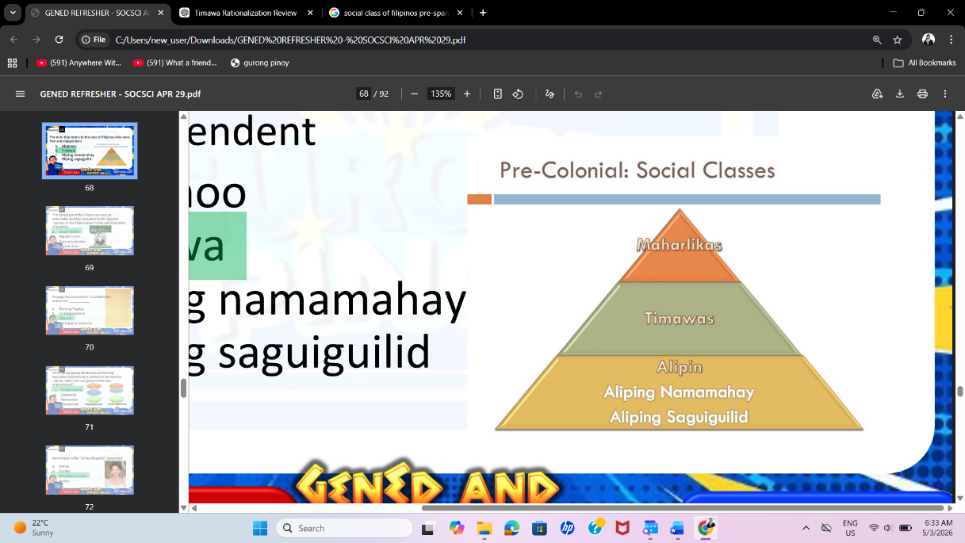
- Timawa
- Aliping namamahay
- Aliping saguiguilid

Rationalization:
- Timawa: free and independent
- Maginoo: nobles (higher class)
- Aliping namamahay: partly free but still serving a master
- Aliping saguiguilid: slaves (not free at all)

24. The campaign of the Filipino seculars to administer parishes occupied by the Spanish regulars or the Filipinization in the administration of parishes
- Secularization
- Regularization
- Contractualization
- Hispanization

Rationalization:
- Secularization: aimed to transfer parish administration from Spanish regulars to Filipino secular priests.
- Regularization: refers to placing parishes under regular priests (friars), which is the opposite of the movement.
- Contractualization: A modern labor term
- Hispanization – The process of making something more Spanish in culture
- Secularization = Filipino priests take over parishes
- Opposite = Regularization (Spanish friars stay in control)

25. Propaganda movement: La Solidaridad ; Katipunan: ___________
- Diariong Tagalog
- La Independencia
- Kalayaan
- Del Superior Govierno

Rationalization:
- The Propaganda Movement used La Solidaridad as its official publication to peacefully push for reforms under Spanish rule.
- On the other hand, the Katipunan, which aimed for complete independence through revolution, had its own newspaper called Kalayaan. It was used to spread revolutionary ideas and recruit members.

26. With the Batasang Pambansa performing legislative and executive powers in the Marcos regime, which form of government was implemented?
- Parliamentary
- Dictatorial
- Monarchial
- Presidential

Rationalization:
- Parliamentary: legislative + executive powers combined

27. With whom is the “Strong Republic” associated?
- Ramos
- Estrada
- Macapagal-Arroyo
- Aquino

Rationalization:
- Gloria Macapagal-Arroyo – Known for “Strong Republic”
- Fidel V. Ramos – Known for “Philippines 2000”
- Joseph Estrada – Known for “Erap para sa mahirap”
- Corazon Aquino – Known for restoring democracy after Martial Law

# | President | Years | Known for / Associated with
1 | Emilio Aguinaldo | 1899–1901 | First President; Philippine Independence (1898)
2 | Manuel L. Quezon | 1935–1944 | “Father of National Language”; Commonwealth
3 | Jose P. Laurel | 1943–1945 | President during Japanese occupation
4 | Sergio Osmeña | 1944–1946 | Restoration of government after WWII
5 | Manuel Roxas | 1946–1948 | First President of the 3rd Republic
6 | Elpidio Quirino | 1948–1953 | Post-war rehabilitation
7 | Ramon Magsaysay | 1953–1957 | “Man of the Masses”; Huk rebellion suppression
8 | Carlos P. Garcia | 1957–1961 | “Filipino First Policy”, Prince of Visayan Poets
9 | Diosdado Macapagal | 1961–1965 | Changed Independence Day (July 4 → June 12)
10 | Ferdinand Marcos | 1965–1986 | Martial Law; New Society
11 | Corazon Aquino | 1986–1992 | People Power; Restoration of democracy
12 | Fidel V. Ramos | 1992–1998 | “Philippines 2000”; economic growth
13 | Joseph Estrada | 1998–2001 | “Erap para sa mahirap”
14 | Gloria Macapagal-Arroyo | 2001–2010 | “Strong Republic”; economic reforms
15 | Benigno Aquino III | 2010–2016 | “Daang Matuwid” (Straight Path)
16 | Rodrigo Duterte | 2016–2022 | War on drugs; Build Build Build
17 | Ferdinand Marcos Jr. | 2022–present | “Bagong Pilipinas”

AQLOR
1. Aguinaldo- First president of the 1st republic, youngest pres (28), longest living pres (94)
2. Quezon- Fr. of National language; commonwealth, 1st senate pres, Fr. of Social Justice
3. Laurel- Japanese, Puppet president, Kalibapi, 1st Pres of second republic
4. Osmeña- WW2, 1st assembly speaker, 1st Visayan Pres, Bell trade act
5. Roxas- First president of 3rd Republic

QUIMGMAMASR
6. Quirino- post war rehabilitation; golden arinola, 1st Ilocano Pres, SSS, Vp of Roxas
7. Magsaysay- Man of masses; hukbalahap suppression, Golden Yrs of PH, Narra, barong
8. Garcia- Filipino First Policy, Prince of Visayan poet, 1st Pres buried in Libingan ng mga bayani
9. Macapagal- Agricultural land reform, poor boy, change independence to June 12
10. Marcos, Sr.- Martial Law, 2nd Ilocano Pres, 21 yrs in office, oath taking in own language

AQRAESARAQIII
11. Aquino- People power, democracy, first female president, family code of 1987
12. Ramos- Philippine 2000, Indigineous people act, peace agreement MILF, British Knigthood UK
13. Estrada- Erap para sa mahirap, First impeached pres, EDSA 2
14. Arroyo- Strong republic, EVAT law, first to take oath-taking outside Luzon
15. Aquino III- Daang Matuwid, K-12 Curriculum, No wang-wang policy

DM
16. Duterte- BBB, War on Drugs, oldest pres, 1st Mindanaoan President,
17. Marcos, Jr.- Bagong Pilipinas, abolished PACC

28. Which of the following is not a function of art?
- Painting
- Personal
- Physical
- Psychological

Rationalization:
- Personal function: art expresses the artist’s feelings, thoughts, and experiences
- Physical function: art serves practical or functional purposes (e.g., furniture design, architecture)
- Psychological function: art affects emotions, mood, and mental state
- Painting is a form or medium of art (a type of visual art)

29. The “what” of an artwork is known as

- Subject
- Form
- Content
- Strategies

Rationalization:
- Form: How
- Subject: What
- Content: Why

30. A student who may not excel academically but has strong interpersonal skills has
- Academic Intelligence
- Emotional Intelligence
- Affective intelligence
- Values intelligence

Rationalization:
- Emotional Intelligence (EQ)
- understand one’s own emotions
- empathize with others
- build relationships
- manage social interactions effectively
- Academic Intelligence – focuses on intellectual or scholastic ability (e.g., exams, reasoning)
- Affective intelligence – relates to emotions but is not the standard or widely used term in intelligence theories
- Values intelligence – refers to moral principles

31. What is the Socratic philosophy of the self?
- The self exists in two parts.
- The self is tripartite.
- The self is always single.
- The self has one component.

Rationalization:
- In the philosophy of Socrates, the self is understood as having two aspects:
- the physical body (material, temporary)
- the soul (immaterial, eternal, and the true essence of a person)
- Socrates emphasized that the soul is more important than the body, which is why he encouraged self-knowledge and moral development (e.g., “Know thyself”).
- The self is tripartite: this is associated with Plato (reason, spirit, appetite)

32. The basic need of the self composes which part of the self?
- Soul
- Rational part
- Spirited part
- Appetitive part

Rationalization:
- In the philosophy of Plato, the self (or soul) is divided into three parts
- Rational part – thinks and reasons (mind)
- Spirited part – emotions like courage, anger, and will
- Appetitive part – desires and basic needs

33. The Golden mean advocates living a life of
- Luxury
- Highest pleasure
- Moderation
- Selflessness

Rationalization:
- The concept of the Golden Mean comes from Aristotle. It teaches that a good and virtuous life is achieved by finding the balance between two extremes: excess and deficiency.
- This means living a life of moderation, not too much and not too little.

34. For him, happiness is the end-all and that it can be found in God alone.
- Aristotle
- Plato
- Augustine
- Thomas of Aquinas

Rationalization:
- Augustine → Happiness = God
- Aristotle → Happiness = Virtue

35. For this medieval philosopher, there are truths that cannot be known by the human reason alone but shall also be perceived with the help of the light of divine revelation.
- Aristotle
- Plato
- Augustine
- Thomas of Aquinas

Rationalization:
- Thomas Aquinas taught that truth comes from both reason and faith. He explained that:
- Some truths can be discovered through human reason (e.g., natural laws)
- But there are higher truths (like the nature of God) that cannot be known by reason alone
- These truths require divine revelation (faith, Scripture)
- Aquinas → Faith + Reason
- Augustine → Faith first before understanding

36. Taoism is a Chinese philosophy which is more spiritual than ethical. Its proponent was
- Kung Fu TZE
- Siddharta Gautama
- Lao Tzu
- Mohammed

Rationalization:
- Lao-tzu means “Old Master”
- Founder of Taoism
- Wrote Tao te ching

37. The student asks himself, “What is in it for me?” after presented with the offer to become the Student Council president. In what stage of moral development is he situated?
- Pre-conventional
- Conventional
- Post-conventional
- Cannot be determined

Rationalization:
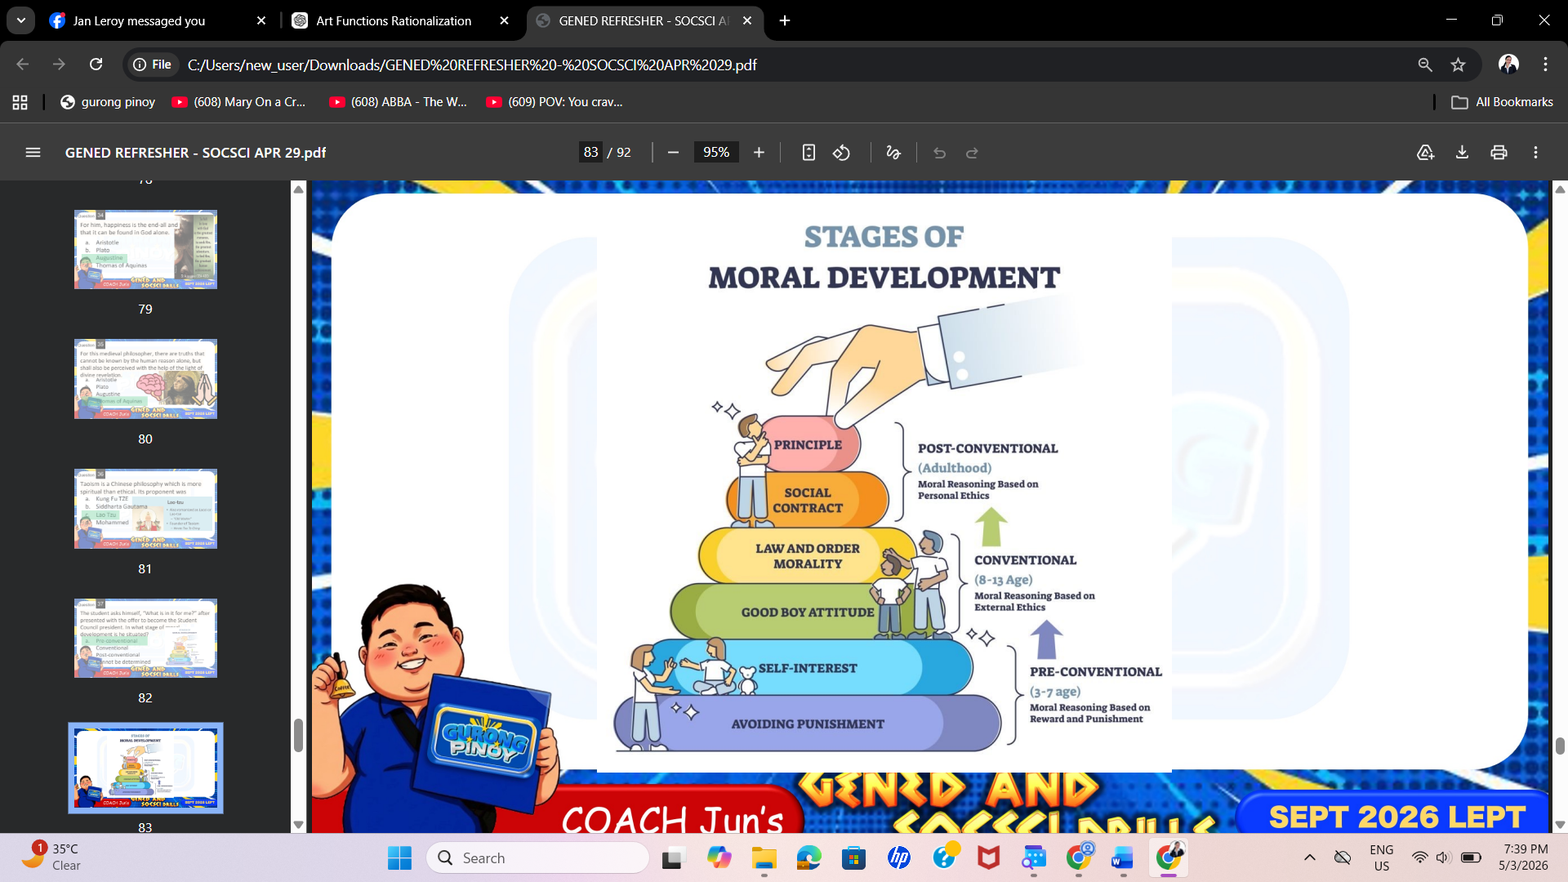

38. The compliance to school rules by the students is a highlight under which stage of moral development?
- Pre-conventional – Instrumental
- Conventional – Law and Order
- Post-conventional – Social Contract
- Post-conventional – Universal Principle

39. A Politician who would like to provide an impression that he is a nice guy has attained which stage of moral development?
- Pre-conventional
- Conventional
- Post-conventional
- Cannot be determined

40. “He is an orphan. Don’t you have any mercy to convict him?” What fallacy of argument is being illustrated?
- Ad hominem
- Ad misericordiam
- Ad verecundiam
- Red herring

Rationalization:
- Ad misericordiam: fallacy of appeal to pity
- Ad hominem: attacks the person, not the argument
- Ad verecundiam: appeal to authority
- Red herring: distracts from the main issue

